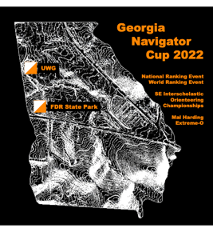
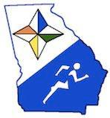
Georgia Navigator Cup – NRE
OUSA Junior National Championships

Mal Harding Extreme-O
January 14th – 17th

Placeholder – Waiting for Updates
Overview
Georgia Orienteering Club is hosting a series of orienteering races over the Martin Luther King Jr holiday weekend. On offer are 3 World Ranking Events (WREs): a Sprint, a Middle and a Long; concurrent with 3 National Ranking Events (NREs): a Sprint and two Classic distance races; and the unsanctioned Mal Harding Extreme-O. The Sprint races are at the University of West Georgia (UWG) in Carrollton, Georgia. The Middle race, Long race, Classic races and Extreme-O are at F.D. Roosevelt State Park in Pine Mountain, Georgia. Georgia Navigator Cup awards will be based on total points for best two of the three races in any class. The Southeast Interscholastic Championships will be awarded under OUSA scoring guidelines for interscholastic classes in the two Classic distance races. The competitive races are open to all ages and abilities.

Locator Map
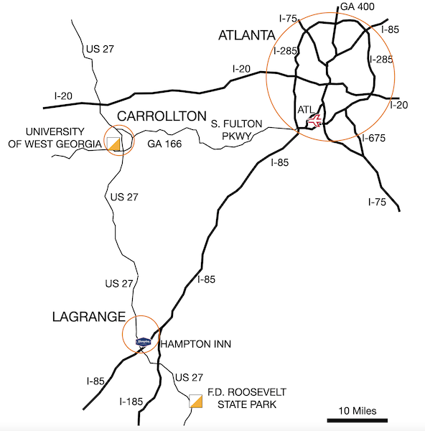
Schedule -- Jan 13-16

Friday Jan 13

- 8:00 am: F.D. Roosevelt State Park practice course opens
- 1:00 pm - 4:00 pm: Packet Pick-Up at Meet HQ University of West Georgia
- 2:00 pm: First WRE Start – Spectating from front of Campus Center before NRE starts
- 3:00 pm: First NRE Start
- 4:30 pm: Last Start
- 5:30 pm: University of West Georgia Courses Close / Control pick-up

Saturday Jan 14

- 8:30 - 12:30 am: Packet Pick-Up at Meet HQ F.D. Roosevelt State Park
- 9:00 am: First WRE Start – Spectating in Ballfield before NRE starts
- 10:00 am: First NRE Start
- 1:00 pm: Last Start
- 4:00 pm: Courses Close / Control pick-up

Sunday Jan 15

- 9:00 - 12:30 am: Packet Pick-Up at Meet HQ F.D. Roosevelt State Park
- 9:30 am: First WRE Start
- 10:00 am: First NRE Start
- 1:00 pm: Last Start
- 4:00 pm: Courses Close / Control pick-up

Due to COVID there will be no Awards Ceremony. Awards will be sent to the winners at a later date.

Monday Jan 16
- 8:30 am: Check-in Extreme-O
- 9:00 am: First Start Extreme-O
- 12:00 noon: Course Closes Extreme-O
General Information

Contacts
Meet Director – Charlie Bleau: 404-276-6558
Registrar -- Rick Shane: 770-820-5361
Search and Rescue (SAR) – Fred Zendt: 678-640-5828

Meet Guide Printing
This guide is only available online. If you need a hardcopy, please print it and bring it with you.

Time Limits
Sprint distance course time limit is 1 hour. Middle distance course time limit is 2 hours. Classic and Long distance course time limits are 3 hours. You must return to the Finish and punch the Finish Control within the time limit, whether you complete your course or not. You must download your ePunch before leaving the finish area.

Cell Phones
Competitors are encouraged to take their cell phones on the courses with them for safety; however, they may not use the phone as a navigational aid for competition. See the race notes for coverage.

Weather and Daylight
Average highs in January are 54 F (12 C) and average lows 31 F (-1 C). Records for the date range from highs of 72F (22 C) to lows of 9F (-13 C). Sunrise is 7:44 am and sunset is 5:55 pm.

Safety
All competitors are encouraged to carry a whistle and to dress appropriately for the weather conditions. You are also encouraged to carry a cell phone to be able to call in an emergency. If your calls do not go through, try text messages. Before starting your course, make a contingency plan. Share your start time, expected finish time and contact details with someone who can raise the alarm. Whistles should only be used in the event of an emergency or serious injury (three short blasts). Blowing the whistle otherwise will result in disqualification. If you are lost after the courses close, you are already disqualified, and it is an emergency. Please blow your whistle so that we can locate you before it gets dark. Although conditions in Georgia are often mild in January, you should be prepared for chilly and wet conditions. If you see a competitor that is hurt, you should help to the best of your ability or go to summon help. Report the injured competitor’s bib number and exact location to officials at the Finish or Start line and the SAR coordinator. In the case of a life-threatening emergency, call 911.
Put the Search and Rescue (SAR) Coordinator number in your cell phone now:

Fred Zendt 678-640-5828

You MUST coordinate the search and rescue of all missing or injured persons through the SAR coordinator. DO NOT INITIATE SEARCH AND RESCUE OPERATIONS ON YOUR OWN.
First Aid Assistance
In the case of a life-threatening emergency, call 911.
First aid kits, an AED and first aid assistance will be located at Meet HQ.
Should you require additional medical aid, the nearest hospital emergency rooms are:

