January 13 - Sprint
Georgia O-Fest 2017
Directions
McIntosh Reserve
1046 W McIntosh Circle
Whitesburg, GA 30185
Directions from Atlanta Airport: follow Maynard H. Jackson Jr. Blvd to Airport Loop Rd. Take S Fulton Pkwy, GA-92 N, GA-166 W and GA-5 S to Burnett Rd/W McIntosh Cir in Carroll County. Turn left onto Burnett Rd/W McIntosh Circle.
Directions from Atlanta: Go west on I-20 to exit 34, then south on GA-5 to Whitesburg. Go 2 miles past Whitesburg, then turn left on W. McIntosh Circle.
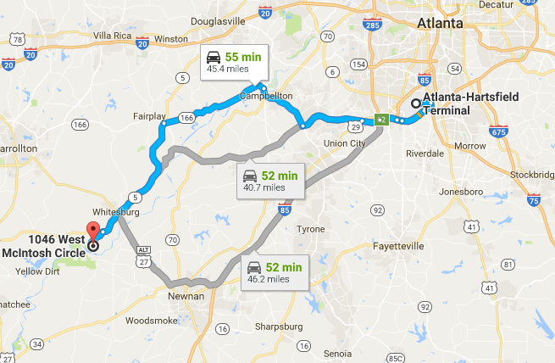

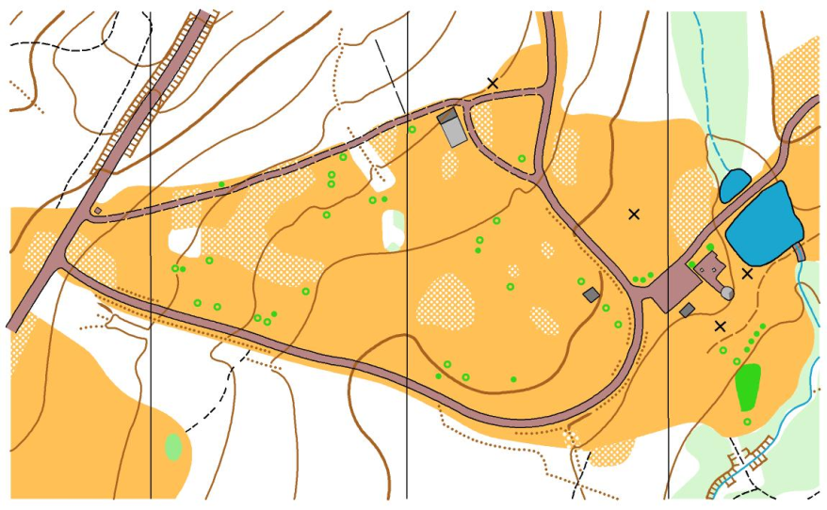
West McIntosh Circle
Friday, January 13 – Event Map
Start
Finish
More Parking
P
Spectators
P
Warm-Up
Area

P
Meet HQ
To GA-5
One Way
Parking
January 14-16: A-Meet and Extreme-O
Georgia O-Fest 2017
Directions
F.D. Roosevelt State Park
2970 Georgia Highway 190
Pine Mountain, GA 31822
GPS Coordinates:
N 32.837533 | W -084.815616

Directions from Atlanta: I-85 South to exit 21. South on I-185 to exit 42. Left on US 27 to Pine Mt., then left on GA 354 to the park.
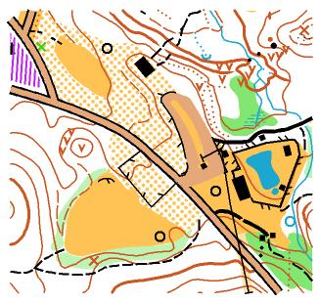
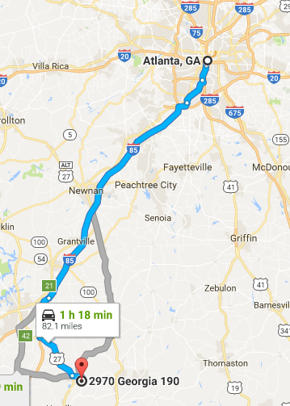
To Pine Mt
& Atlanta

Bus Parking
Food
HQ Tent
Finish
Walk to Start
Car Parking
S. edge of field
Car Parking
S. edge of field
Bus Parking
Hwy 354
Hwy 354
To Pine Mt
& Atlanta

Walk to Start
HQ Tent
Finish
Food

