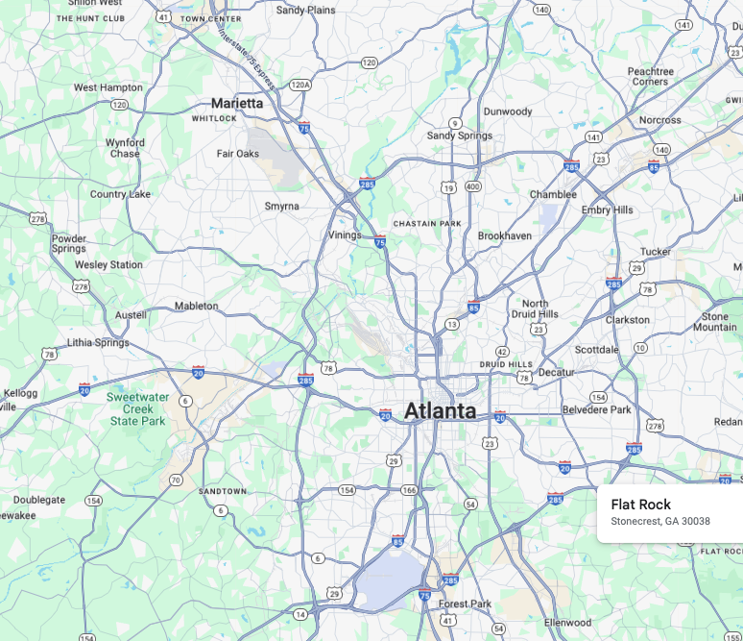
Hartsfield-Jackson Atlanta Airport

