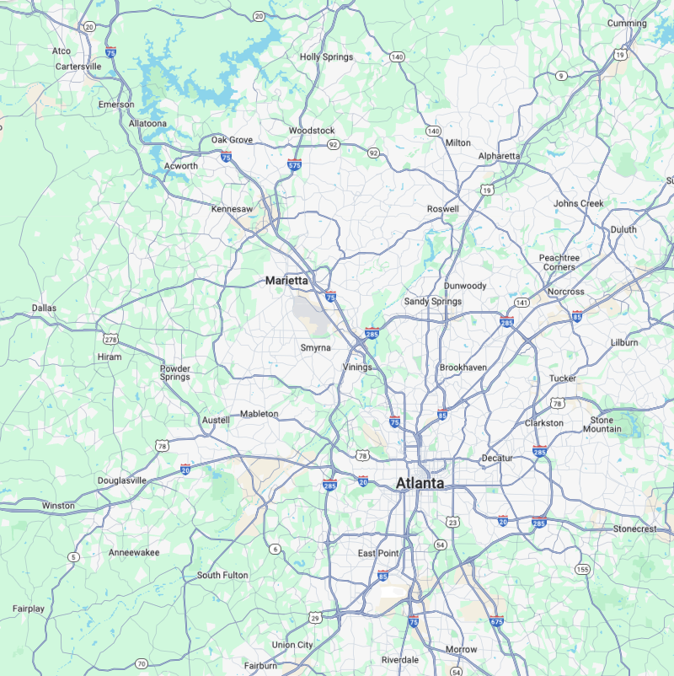
Atlanta Hartsfield-Jackson Airport
Sweetwater Creek State Park
Red Top Mtn State Park

